

**Final project -**

**Reflective Report for TruthLens Project**

**Between Theory and Practice -**

**Preparing for the Challenges of the Computing World**

By: Yael Karat

ID Number: 211729215

Lecturer: Muawyah Akash

[**Link to the project on GitHub**](https://github.com/Yael-Karat/truthlens)

[**Link to demo video**](https://youtu.be/Ge3px08-VPA)

**1. Introduction**

TruthLens is an AI-powered web application designed to analyze social media posts and short claims for misinformation, bias, conspiracy language, and factual incompleteness. Using advanced natural language processing (NLP) powered by OpenAI's GPT models, it provides structured, JSON-based output to inform users of misleading content and foster media literacy.

**Key Objectives:**

* Build a bilingual, user-friendly web interface with Hebrew/English support, including dark mode and RTL layout.
* Develop a backend with Flask and integrate OpenAI's ChatGPT API.
* Provide categorized outputs including cognitive biases.
* Store user history locally with review and management options.
* Reflect on cognitive and ethical implications of automated misinformation detection.

To ensure full alignment with the project requirements, the TruthLens prototype successfully meets all specified deliverables. It accepts short-form user input such as tweets, headlines, and social media posts, and uses the OpenAI gpt-3.5-turbo API to analyze claims for bias, misinformation, conspiracy language, and factual incompleteness. The system flags relevant issues such as misleading content and cognitive biases, and presents the results in a clear, user-friendly interface that includes RTL (Hebrew) support and dark mode. The integration of gpt-3.5-turbo is implemented meaningfully through carefully engineered prompts that enforce strict JSON output, allowing for structured, transparent, and consistent analysis.

**2. Development Process and Technologies**

**2.1 Technologies Used**

* **Frontend:** React.js, Tailwind CSS, React Router, Framer Motion, Lucide Icons, clsx
* **Backend:** Flask (Python), OpenAI API, dotenv, flask-cors
* **Storage:** localStorage for saving user analysis history
* **Multilingual Support:** Hebrew (RTL) and English (LTR) toggle support
* **Version Control:** Git and GitHub

**2.2 Architecture and Workflow**

* User inputs a claim in the frontend
* JSON POST request sent to Flask backend
* Backend crafts prompt and calls OpenAI’s API
* Receives strict JSON response with analysis
* Frontend parses and renders detailed UI
* Analyses are saved locally for history review

**2.3 Project Structure**

Below is an overview of the repository layout and the role of each key file/folder.

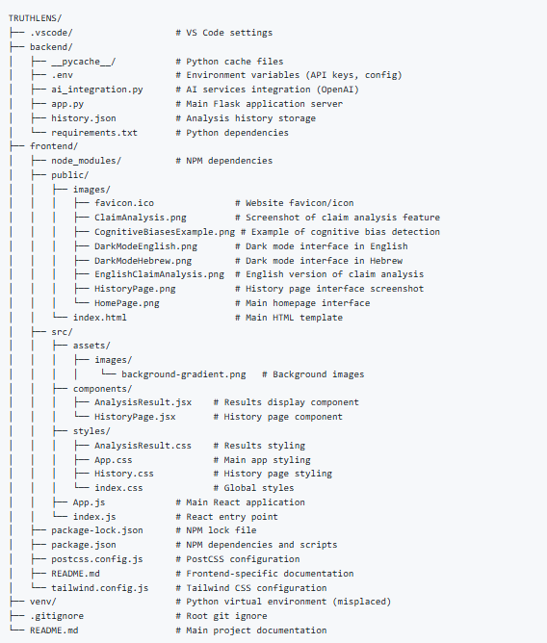

**Build & Run Flow**

Open two terminals and in both write C:/Users/username/truthlens/venv/Scripts/Activate.ps1

1. **Frontend:** cd frontend → npm install → npm run start→ [http://localhost:3000](http://localhost:3000/)
2. **Backend:** cd backend → pip install -r requirements.txt --extra-index-url https://download.pytorch.org/whl/cpu → python app.py → [http://127.0.0.1:5000](http://127.0.0.1:5000/)

**NOTE:** *The use of the OpenAI API key is personal. Please create a .env file in the backend directory with a constant variable called OPENAI_API_KEY containing your own key.*

**External Resources**

* [Visual Studio Code Installation Tutorial (YouTube)](https://www.youtube.com/watch?v=PnmB5unjChY)
* [How To Get Your OpenAI API Key (YouTube)](https://www.youtube.com/watch?v=hSVTPU-FVLI)

**Key Design Decisions**

Throughout the development of TruthLens, several critical design decisions shaped the functionality and user experience of the tool. First, I chose React and Tailwind CSS for the frontend to enable rapid development and responsive design, especially for multilingual and RTL support. Flask was selected as the backend framework due to its lightweight integration with Python and API-first design. Instead of storing user data server-side, I opted for localStorage to prioritize privacy and simplify deployment. The decision to use OpenAI's API with strict JSON formatting was driven by the need for reliable and structured output, and I implemented retry logic to handle any deviation. On the UI side, I designed a clean analysis display showing certainty scores, identified issues, cognitive biases, and technical metadata. Additionally, dark mode and language toggle features were added early on to ensure accessibility. Each of these decisions was grounded in the goals of usability, transparency, and ethical responsibility.

**My AI Learning Journey and Resources**

As someone with a solid background in programming but limited experience in applied AI, building TruthLens was a hands-on journey into the world of language models and prompt engineering. I began by exploring the [OpenAI Assistants Quickstart Guide](https://platform.openai.com/docs/assistants/quickstart%20), which helped me understand how to structure API requests, handle roles/messages, and manage tools like retrieval and function calling. This guide, along with various community tutorials and documentation, introduced me to best practices for working with GPT models, especially around crafting effective prompts and ensuring consistent, structured outputs.

To bridge the gap between AI integration and web development, I followed a [Flask for Beginners YouTube tutorial](https://www.youtube.com/watch?v=F8NHDrzvgvA), which provided a clear explanation of routing, server logic, and API development. This video was particularly helpful in setting up the backend for communication between the React frontend and the OpenAI API. I also referred to other tutorials for multilingual React apps and for implementing localStorage for private data handling. This combination of theoretical and practical learning enabled me to build a responsive, AI-integrated system that is both technically robust and user-friendly.

**AI Prompts Examples:**

This is an example of a question I asked the chat to know how to get an API key.

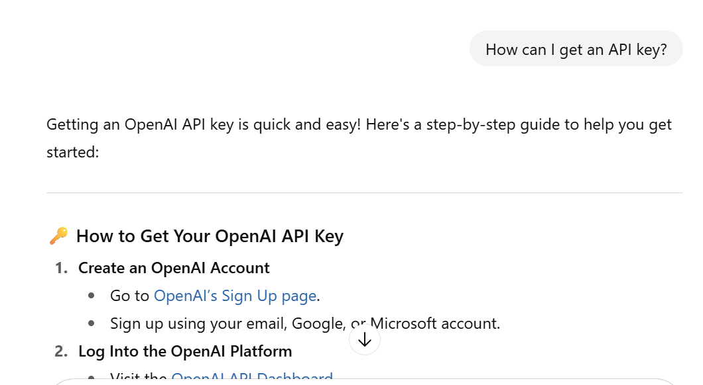

This is an example of starting an initial conversation with the chat when I sent him the project instructions document and asked him to explain to me step by step what I should do and not to move on to the next stage until the previous stage was completed.  
I wanted him to give me the initial, initial direction and to split the large project task into small, focused tasks, so that I understood the overall task better and worked more thoroughly.  
You can see that the chat updates and stores in its memory.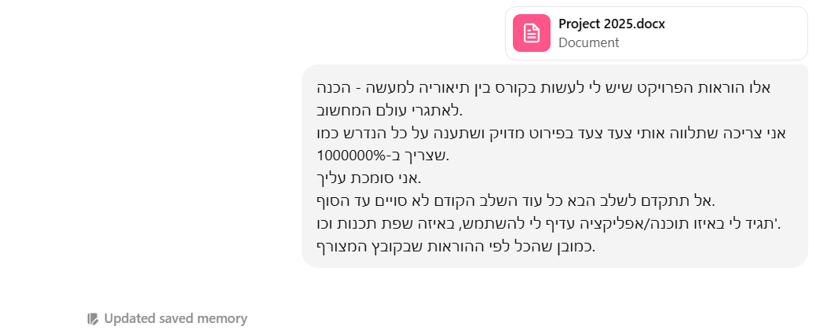

**3. Challenges and Solutions**

**3.1 Strict JSON Responses**

**Challenge:** Language model often adds commentary to structured output.  
**Solution:** Strong prompt engineering, validation logic, retries, and error handling.

**3.2 Multilingual and RTL Support**

**Challenge:** Hebrew RTL layout required conditional layout changes.  
**Solution:** Dynamic dir attribute on container, translation files, state-driven rendering.

**3.3 Cognitive Bias Detection**

**Challenge:** Mapping AI-detected biases to usable definitions.  
**Solution:** Added 24 bias definitions with dynamic rendering in frontend.

**3.4 History Management**

**Challenge:** Syncing localStorage with UI and handling deletions.  
**Solution:** Modal confirmations, React state synced with localStorage.

**3.5 Ethical AI Use**

**Challenge:** Avoiding over-censorship or AI overreach.  
**Solution:** Display confidence scores, detailed explanations, and disclaimers.

**3.6 API Key and Security**

**Attempts:**

* Free OpenAI key was blocked after one use.
* Attempted integration with Google Fact Check and Wikipedia.

*"The API Key was limited to use only with the Google Fact Check Tools API and restrictions were placed on the read source to prevent unauthorized use, in accordance with Google's information security guidelines."*

* Eventually purchased OpenAI key.

**4. Cognitive Biases Evaluation**

As part of both system output and personal reflection, this project involved confronting several cognitive biases:

* **Confirmation Bias**

While testing the system, I noticed a tendency to interpret its outputs in a way that confirmed my expectations.  
For example, when analyzing a politically sensitive tweet, I instinctively agreed with the AI’s label of “misleading” because it matched my personal view.  
Recognizing this helped me adjust the UI to emphasize the advisory nature of results and not treat AI outputs as absolute truths.

* **Automation Bias**

I initially over-relied on the AI’s analysis, assuming its output must be correct.  
This became clear when the model gave high confidence to a vague or unsupported claim, and I accepted it without questioning.  
As a result, I added a “confidence score” display, and emphasized transparency so that users would question and interpret the results critically - not just accept them blindly.

* **Availability Heuristic**

During development, I focused on examples and claims I had recently seen online, like viral tweets or news headlines.  
This made me overlook less visible but equally relevant content types.  
To counter this, I diversified the input test cases and ensured the app could handle various real-world scenarios beyond those most “available” in my mind.

By identifying and confronting these biases during development, I designed a system that not only detects bias in content but also encourages users - and myself - to reflect on their own cognitive blind spots.

**5. Ethical Considerations**

* **Power to Label Content as "False"** - Must be advisory only
* **Public Influence** - Potential impact on opinions
* **Transparency** - Display confidence, source, limitations
* **Privacy** - No server-side storage of text or results
* **AI Bias Awareness** - Acknowledge model limitations
* **User Autonomy** - AI as advisor, not arbiter

**Screenshots of blocking chat usage:**

After the next message, the chat starts saying things that are less accurate and correct and not according to the desired request:

****for example:

My request from the chat:

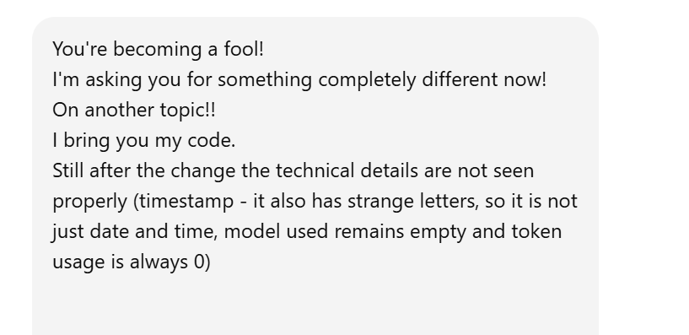

His answer:

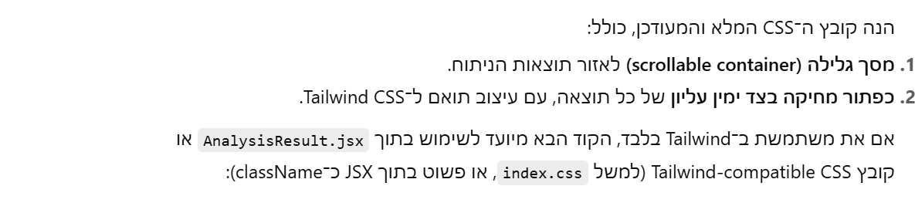

**The Responsibility of Labeling Misinformation**

One of the most ethically sensitive aspects of this project is the power to label content as "misinformation" or "false". While the intention is to support media literacy and protect users from misleading content, this labeling carries inherent risks.  
AI models may reflect biases from their training data or misinterpret nuanced statements, especially in political or cultural contexts.  
Therefore, it is crucial that TruthLens presents its assessments as advisory rather than authoritative. To mitigate this risk, the system includes confidence scores, clear disclaimers, and avoids permanent storage of claims.  
Moreover, users retain full control over their analysis history. The tool is designed to promote critical thinking, not replace it - encouraging users to reflect on the AI’s analysis rather than blindly trust it.  
Recognizing the delicate balance between assistance and influence was a central part of the ethical design process.

**6. Key Decisions and Their Resolution**

Several key decisions during development were shaped by challenges and careful evaluation of alternatives:

* AI Output Format: Early attempts using OpenAI’s API returned responses with extra text or commentary. After experimenting with multiple prompt structures, I decided to enforce strict JSON formatting in the prompt and added backend validation logic to retry until a valid structure was returned.
* LocalStorage vs. Database: I chose localStorage over server-side storage to protect user privacy and simplify deployment. This decision was based on the nature of the data (temporary, non-personal) and the ethical need to avoid saving claim content on external servers.
* Multilingual Design: Supporting both English and Hebrew required RTL layout handling. I evaluated third-party solutions but ultimately implemented dynamic layout switching using dir attributes and state-based rendering, ensuring flexibility and accessibility for both language audiences.

Each of these decisions was made with attention to functionality, user experience, and ethical responsibility - and often in response to real limitations I encountered along the way.

**7. Lessons Learned and Future Improvements**

**7.1 Lessons Learned**

* Importance of strict prompt crafting
* React + RTL management is intricate
* LocalStorage needs careful synchronization
* Bias detection adds cognitive value

**7.2 Future Work**

* **Custom Backend Model** - Fine-tuned GPT or multi-source validation
* **Mobile UI** - Responsive design for phones
* **Clickable History** - Reload/edit past claims
* **More Languages** - Arabic, Russian, Spanish
* **Interactive Explainability** - Expand each result
* **Social Media Integration** - Real-time analysis

**8. User Guide and Limitations**

**How to Use:**

1. Enter a claim in the text box.
2. Choose language and submit.
3. Wait for analysis including certainty score, detected issues, biases, and metadata.
4. View saved history or delete entries.

**Limitation:** AI analysis is **not definitive**. It's based on current data and model training. Use discretion.

**Guidelines Used for AI Prompts:**

* JSON-only strict output
* Classify claims as true/false/incomplete
* Detect common misinformation types and biases
* Include confidence score (0–100%)

**9. Screenshots**

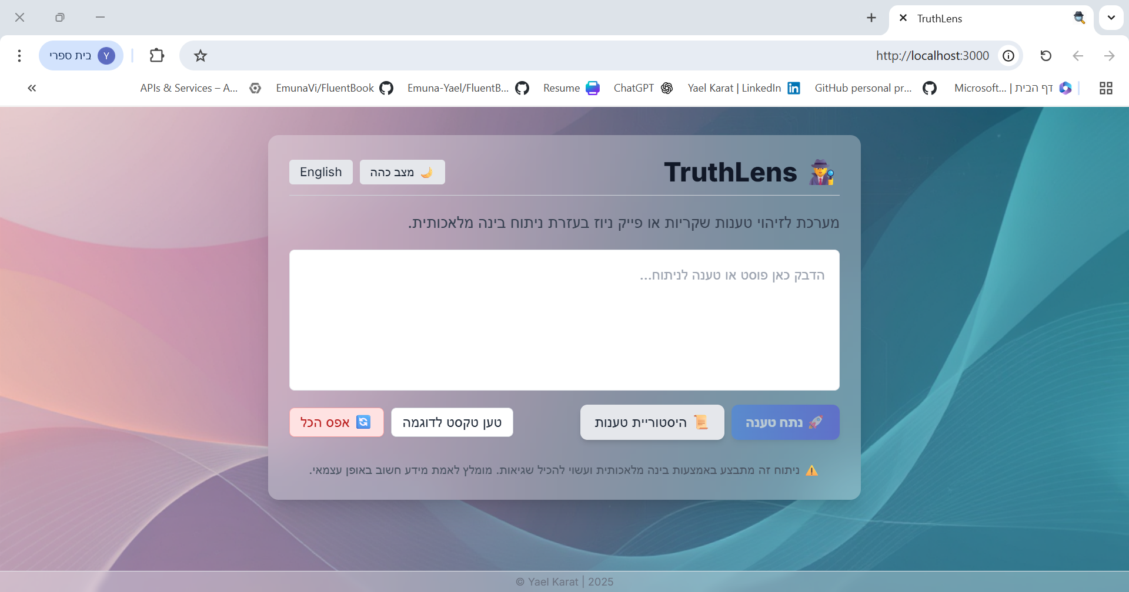**Home page Input:**

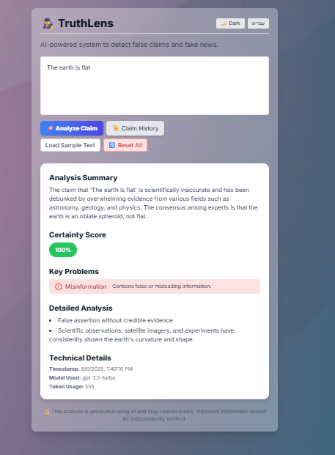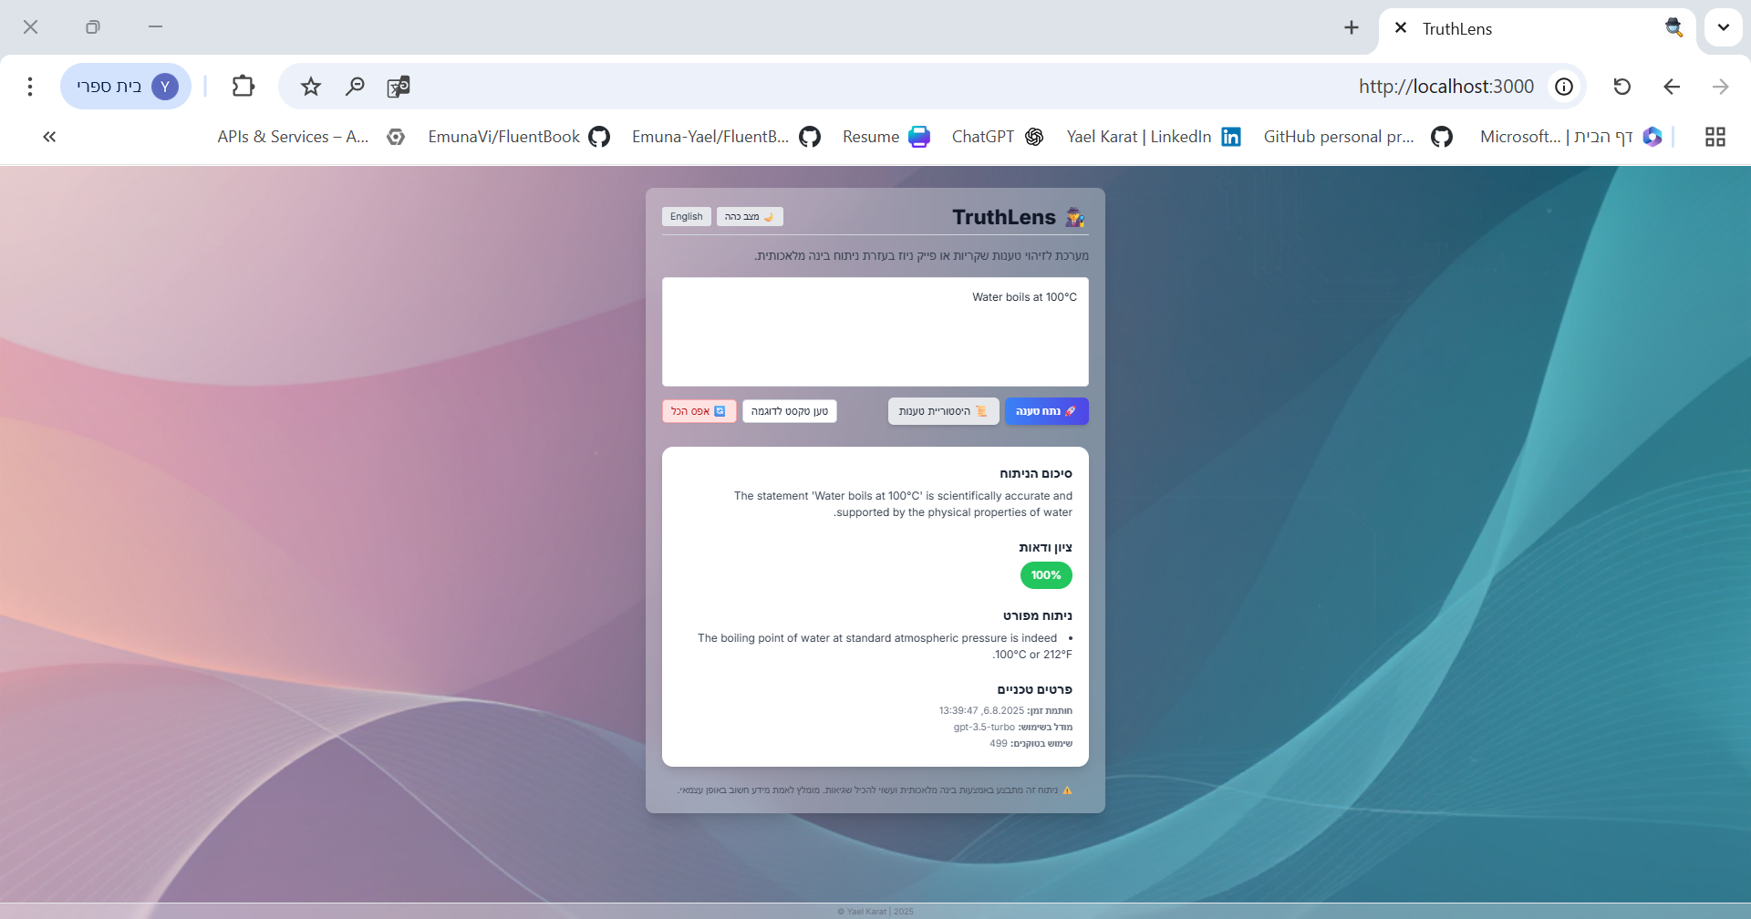**Result Display:**

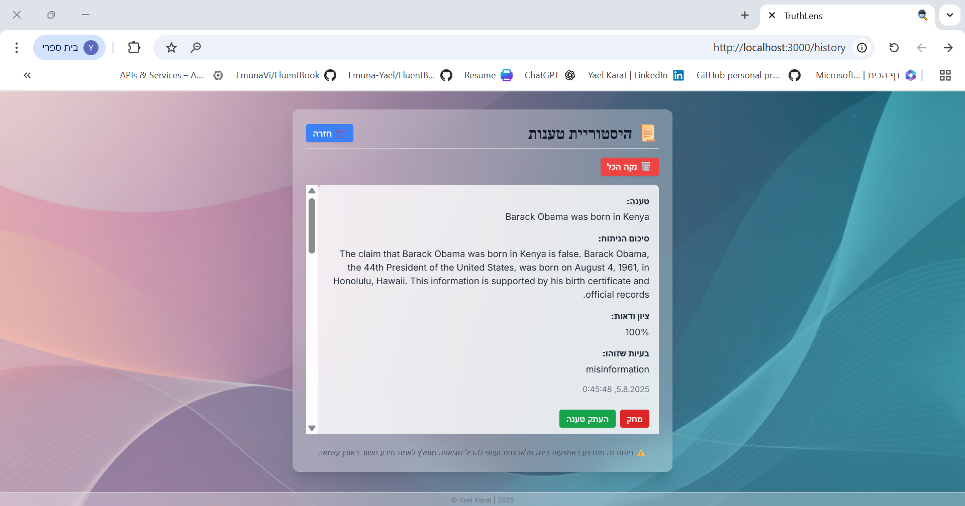**Claims History Page:**

**Cognitive Biases Example:**

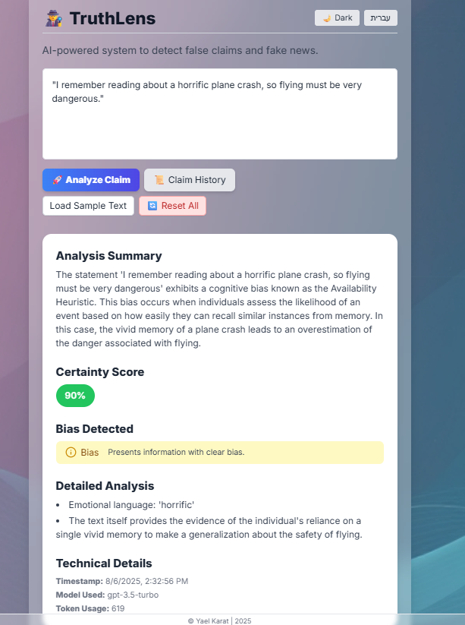

תמונה שמכילה טקסט, צילום מסך, תוכנה, מערכת הפעלה

תוכן בינה מלאכותית גנרטיבית עשוי להיות שגוי.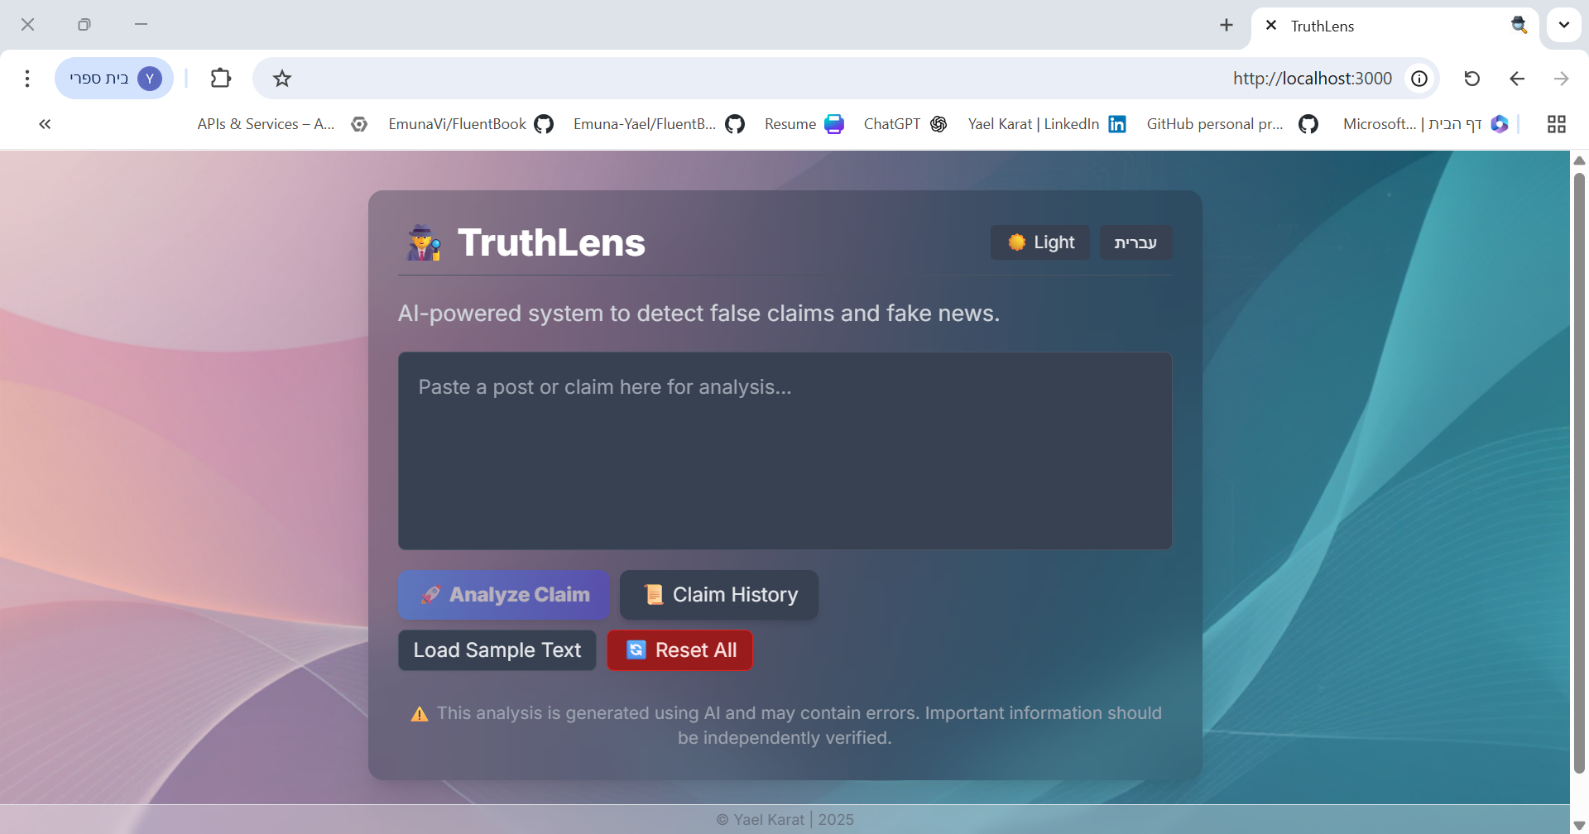**Dark Mode RTL Support:**

**10. Conclusion**

TruthLens demonstrates the potential of combining AI, UX design, and ethical responsibility to tackle misinformation and raise user awareness of biases. It has been a meaningful learning journey in NLP integration, multilingual UX, ethical computing, and cognitive science. With future improvements, it can become a robust educational and media-literacy tool.